**ASSIGNMENT-IV**

**FERTILIZER RECOMMENDATION SYSTEM FOR DISEASE PREDICTION**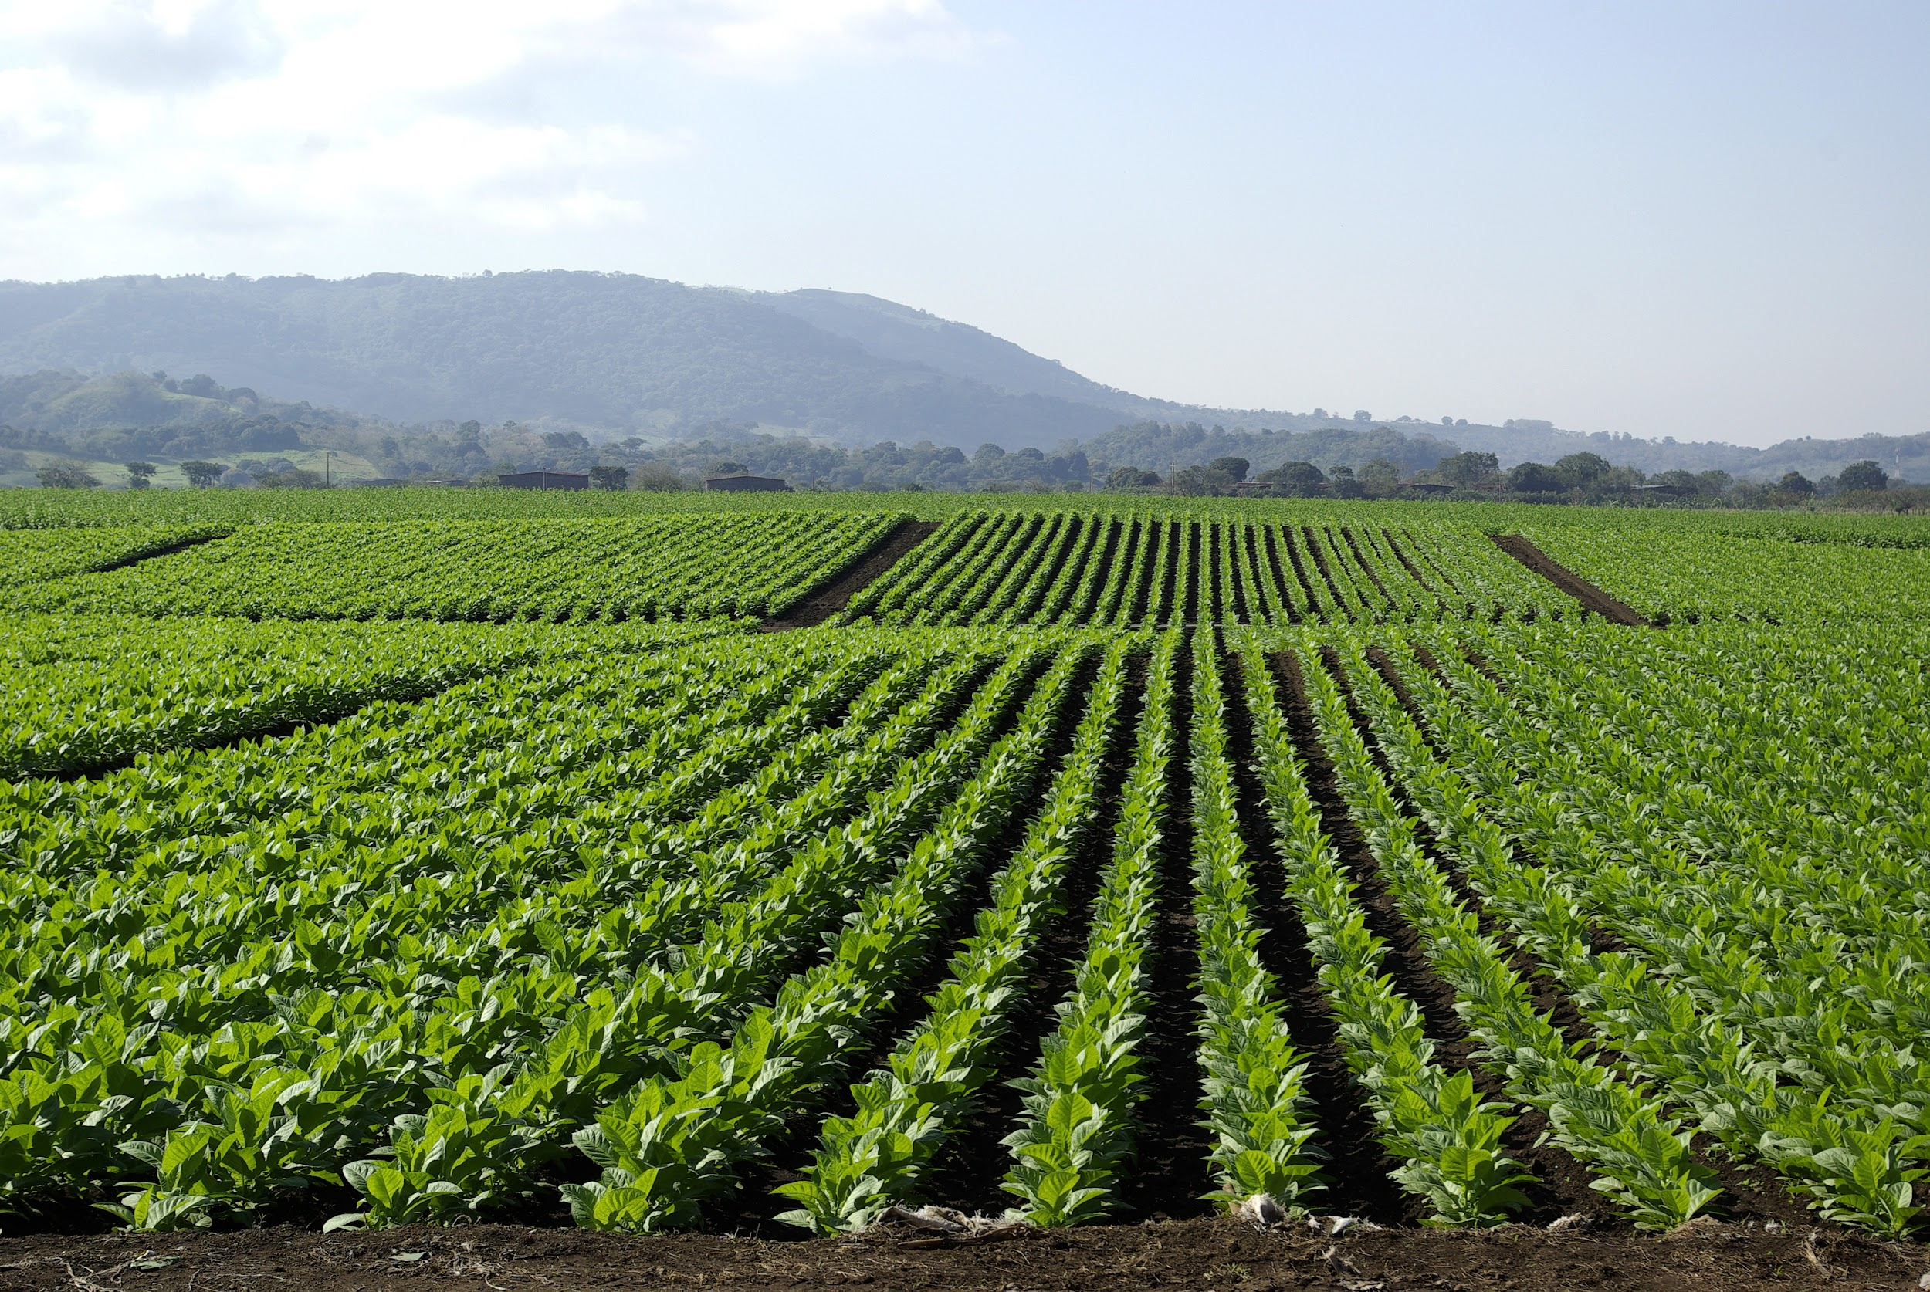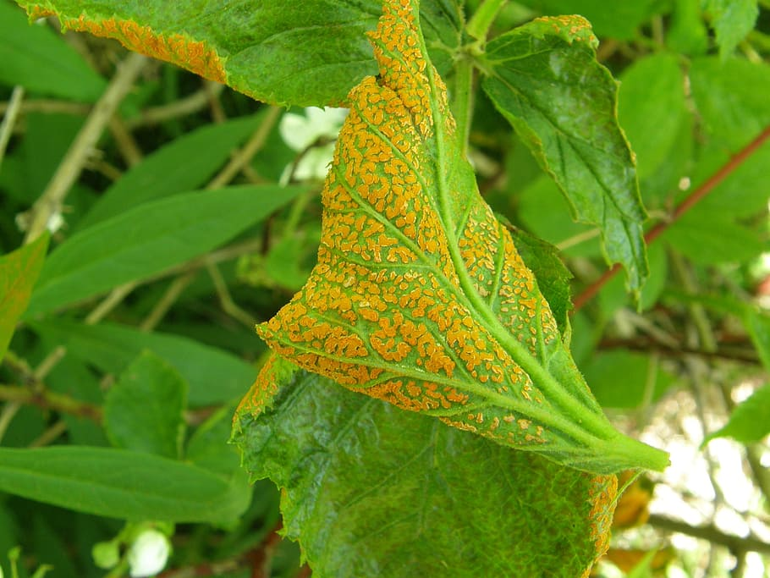

| **DATE** | **31 october 2022** |
| --- | --- |
| **STUDENT NAME** | **1.MATHIARASI.J(TEAM LEADER)-622219104015**  **2.P.SANDHIYA -622219104024**  **3.R.KAVIPRIYA-622219104010**  **4.M.MAMTHA-622219104030**  **5.S.SAABIRA-622219104023** |
| **MAXIMUM MARKS** | **2 marks** |
| **MARK ALLOTTED** |  |

**SOURCE CODE:**

**Import pandas as pd**

**Import numpy as np**

**Import matplotlib.pyplot as plt**

**Import seaborn as sns**

**From sklearn_selection Import train_test_split**

**From sklearn.preprocessing**

**Import labelEncoder**

**From tensorflow.keras.models Import model**

**From tensorflow.keras.layers import LSTM,Activation,Dense,Dropout,Input,Embedding**

**From tensorflow.keras.optimizers import RMSprop**

**From tensorflow.keras.preprocessing.text import tokenizer**

**From tensorflow.keras.Utils import to_categorical**

**From tensorflow.keras.callbacks import EarlyStopping**

**%matplotlib inline**

**Import csv**

**With open(‘/spam.csv’,’r’) as csvfile;**

**reader=csv.reader( csvfile)**

**df=pd.read_csv(r’/spam.csv’,encoding=’latin-1’)**

**df .head()**

| **s.no** | **V1** | **V2** | **Unnamed 1** | **Unnamed 2** | **Unnamed 3** | **Unnamed 4** |
| --- | --- | --- | --- | --- | --- | --- |
| **1** | **ham** | **Go until jurong point,crazy..Available only…** | **NaN** | **NaN** | **NaN** | **NaN** |
| **2** | **spam** | **Ok lar joking with u only…** | **NaN** | **NaN** | **NaN** | **NaN** |
| **3** | **ham** | **Free entry in 2 a weekly comp to win FA cup final.** | **NaN** | **NaN** | **NaN** | **NaN** |
| **4** | **ham** | **Nah I don’t think** | **NaN** | **NaN** | **NaN** | **NaN** |